Hybrid Fingerprint Recognition
Junichi Sakamoto
DDS
http://www.dds.co.jp/en/index.html
sakamoto_junichi@dds.co.jp

Stephen Miller
Aim8 Product Development
smiller@aim8.com

Draft
7 July 2008
Abstract:
Minutia based fingerprint recognition algorithms have been widely accepted as a standard for single finger recognition applications. This technology has proved to be a reliable form of enrollment and matching in a corporate environment under idea circumstances. However, the difficulties associated with race, age, application ergonomics, and user interaction often lead to difficult enrollments with verifications requiring multiple attempts.

Japan-based biometric company DDS has addressed many of these issues by developing an algorithm, called Spectrum Analysis, which evaluates the fingerprint image through horizontal slices. This proprietary technology has proven easier for enrollment and verification with difficult images. However, the technology does require strict adherence to the ergonomic requirements.

To produce the most accurate results under good and difficult environments the company combined two technologies together. This Hybrid Fingerprint technology utilizes a technique called “Shading” where information or lack of information from both algorithms is used to form a decision.

This paper addresses the technical aspects and benefits of a hybrid fingerprint recognition algorithm.

Introduction
Minutiae based fingerprint algorithms require highly accurate templates for enrollment. Many fingers are difficult to enroll due to issues in race, sex, age, and occupation [1]. Moreover, obtaining quality templates in a non-perfect world of poor image quality and application ergonomics can require multiple attempts by trained and untrained users [2]. In a consumer based model, this can lead to increased support costs, costs of sales, and user resistance to technology acceptance.

In attempt to address many of the issues there have been numerous recognition technologies developed. Most technologies, while demonstrating particular strengths, also have weaknesses associated with them.

Japan-based DDS has addressed many of these issues by developing a hybrid algorithm. This technique combines their proprietary Spectrum Analysis algorithm with a minutiae base algorithm. Both information and/or lack of information from the results of each can make a decision.

History of Fingerprint Recognition
Fingerprint imaging technology has been in existence for centuries. The use of fingerprints as a unique human identifier dates back to second century B.C. China, where the identity of the sender of an important document could be verified by his fingerprint impression in the wax seal [3].

The first modern use of fingerprints occurred in 1856 when Sir William Herschel, the
chief magistrate of the Hooghly district in Jungipoor, India, had a local businessman,
Rajyadhar Konai, impress his handprint on the back of a contract. Later, the right index and middle fingers were printed next to the signature on all contracts made with the locals. The purpose was to frighten the signer of repudiating the contract because the locals believed that personal contact with the document made it more binding. As his fingerprint collection grew Sir Herschel began to realize that fingerprints could prove or disprove identity [4].
The 19th century introduced systematic approaches to matching fingerprints to certain individuals. One systematic approach, the Henry Classification System, based on patterns such as loops and whorls, is still used today to organize fingerprint card files [5].
In the late 1960’s NEC worked with the FBI and the Home Office in London, which had been working on a system for New Scotland Yard from the late 1960’s, to eventually develop a minutia-based fingerprint identification system. It was initially installed in Tokyo in 1981 and in San Francisco in 1983.
The first country to adopt a national computerized form of fingerprint imaging was Australia in 1986, which implemented fingerprint imaging technology into its law enforcement system [6].
In 1996 after nearly a year of study, the National Institute of Standards and Technology has been convinced that minutia is an acceptable way to store fingerprint biometric data on smart cards.
With the NIST acceptance of minutia it became inevitable this would set an industry standard.

Minutia-Based Algorithm
Minutia-based algorithms extract information such as ridge ending, bifurcation, and short ridge from a fingerprint image.

 |  | 
Short Ridge | Ridge Ending | Bifurcation
(Image source Wikipedia)

These features are then stored as mathematical templates. The identification or verification process compares the template of the live image with a database of enrolled templates (identification), or with a single enrolled template (authentication).
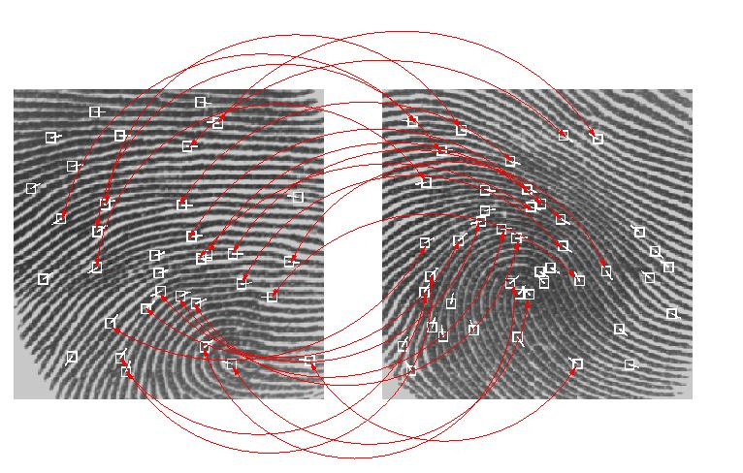
(Image source National Institute of Standards and Technology)

People with no or few minutia points (special skin conditions) cannot enroll or use the system effectively. This is exemplified by the fingerprint immigration programs where finger moistening peripherals are standard. Moreover, a low number of minutia points can be a limiting factor for security of the algorithm. This can lead to false minutia points (areas of obfuscation that appear due to low-quality enrollment, imaging, or fingerprint ridge detail). In an application environment, enrollment without assistance may take several attempts due to poor position or lack of pressure. While not quantified, user frustration will certainly have a negative impact on technology acceptance.

Moreover, the widely used minutiae-based representation does not utilize a significant component of the rich discriminatory information available in the fingerprints. [8]

Spectrum Analysis
Utilizing research from Nagoya Institute of Technology Graduate School in Japan, DDS has developed an algorithm based on Spectrum Analysis. This technique captures cross sections of a sliced fingerprint pattern and converts them to waves. Spectrum analysis uses the spectral series of the waves as feature information, finding the maximum correlations in the wave and verifies the identity of the fingerprint.
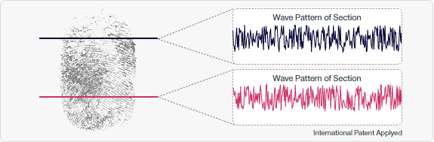
This algorithm of spectrum analysis works extremely well because this algorithm extracts characteristics from the concavo-convex information of a fingerprint without being influenced by the position of the characteristic points used in the conventional Minutia and Pattern-matching method.

In the course of verification under the spectrum analysis algorithm, it is not necessary to store the fingerprint image itself in the system which eliminates the possibility of exposure or leakage of fingerprint images. In principle, it is impossible to regenerate original fingerprint image from the extracted characteristics of images. This addresses issues raised by the IEEE [9] on fingerprint reconstruction of minutiae based systems.

The algorithm performs extremely well in controlled environments where positioning of the finger in enrollment and verification are similar. However, with disparate fingerprint positioning for enrollment and verifications results can be less than desired. This requirement limits the application developer to more controlled ergonomic environments and may reduce some commercial viability.

The Hybrid technology
To accentuate the strengths of both the Spectrum Analysis and Minutiae-based algorithm and limited the inherent weaknesses, the company has combined both algorithms and created a Hybrid algorithm. The combined technology provides for rapid and accurate enrollment and verification in difficult environments.

This Hybrid algorithm extends beyond combining scores from both techniques to form a single decision; instead the technology utilizes a proprietary technique of “Shading”. Shading analyzes the scores of both results and places and associates an importance value with each. Using an algorithm based upon a database of past results, a final score is calculated by using the individual results as a function of importance.

With Shading, if one score is high and one is low, more decision weighting is placed upon the higher score. If both scores are low then information from both are weighed more equally and the results are combined together for a final decision. This ability allows for both algorithms to have low scores and still be accurate.

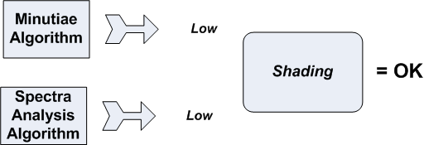

The technology addresses both the strengths of both as well as the challenges. Spectrum analysis can work well with poor image quality and difficult to read fingerprints and minutiae-based algorithms can work very well with angles.

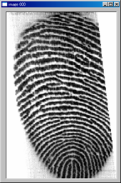 | 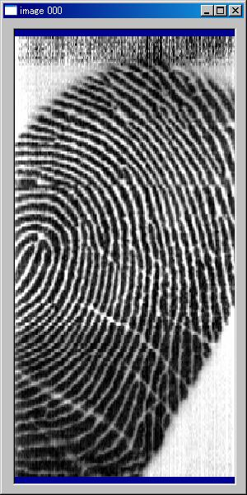 | 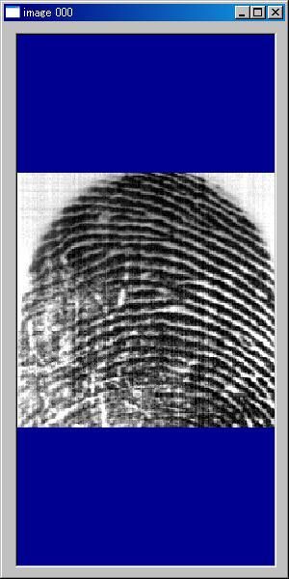
Hybrid Enrollment Examples

Conclusion
By combining the Spectrum Analysis algorithm and Minutiae based algorithms together, the Hybrid technology brings better performance by utilizing the benefits of both algorithms. Moreover, by applying a shading algorithm the technology enhances difficult to read fingerprints caused by poor print quality and poor application ergonomics.

With a more flexible enrollment and matching capability, the system works well with difficult fingerprints, user ergonomics, and partial captures. With this increased robustness, application developers are less restricted with end user applications. Thus is produced a lower cost of support and lower costs of sales as well as less resistance to technology.

[1] Miller, Christiansen 1995; commercialization of fingerprint technologies

[2] Prabhakar and Jain; Introduction to Biometric Recognition Technologies and Applications
[3] Ruggles 1996; http://et.wcu.edu/aidc/BioWebPages/Biometrics_Finger.html
[4] Authentec, Inc., 1999 http://www.authentec.com/history.htm
[5] Precise BioMatch™ Fingerprint Technology; Ola Svedin April 2004
[6] Simon, D. G. 1994
[7] Fingerprint Image Reconstruction from Standard Templates; Raffaele Cappelli
[8] www.advancedsourcecode.com/fingerprint.asp
[9] Fingerprint Image Reconstruction from Standard Templates; Cappelli, Lumini, Maio, IEEE, 2007

